Lab2 Notes

Exercise 1

You should publish before reloading the page if you want to keep the scripts. There is no need for the scripts in the later labs.

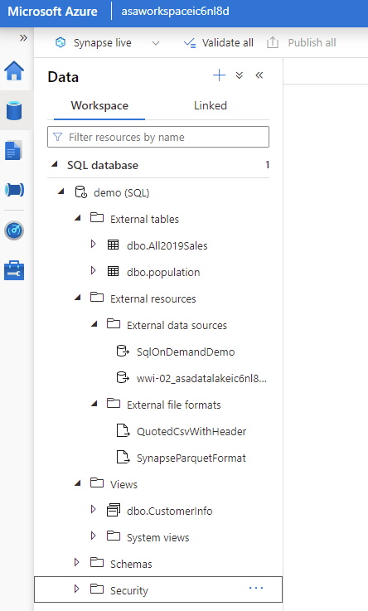

Exercise 2

You might need to move to another window in AD and then return to Groups to see the new group. Even the refresh button might not show anything. Same for members of a group. I had to click refresh many times.

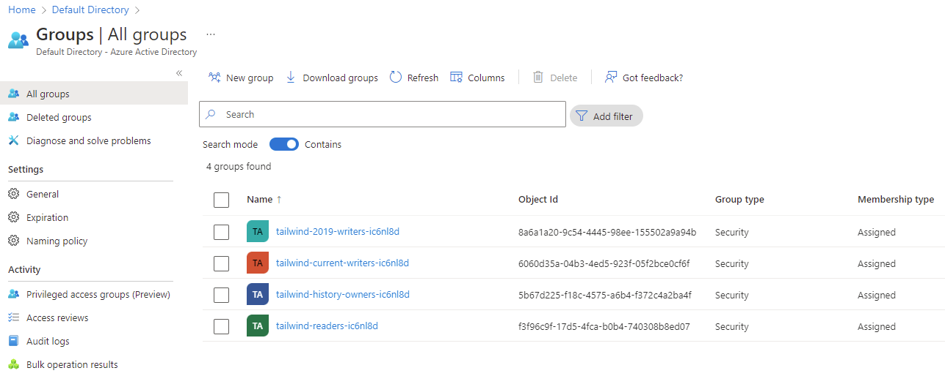

Task 3.10

Removing your account might cause errors in a later lab if you miss task 5.14 that asks you to add your account to tailwind-history-owners. As you can see below, tailwind-history-owners is a member of Storage Blob Data Owner, so removing your account now will have no consequences if you indeed complete task 5.14 later.

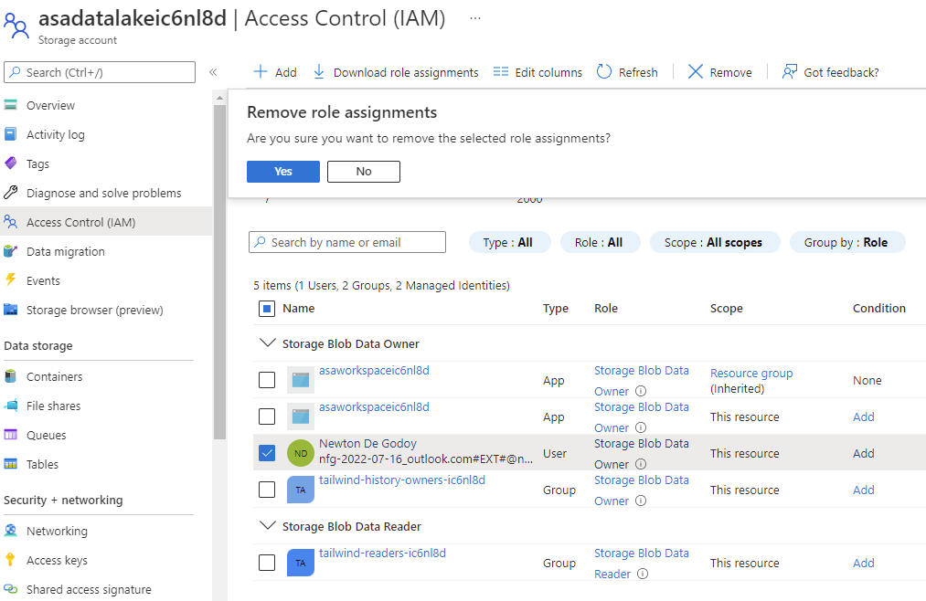

Task 5.14

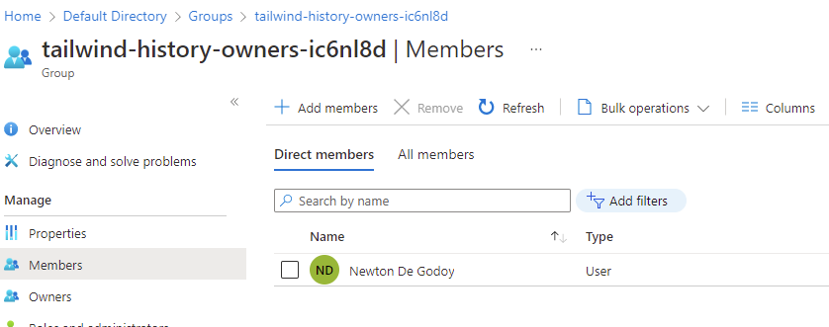

Note that in the task to test the permissions we copied 2019 data to 2016 folder. As it’s just to see that now our account has permission to write, it’s fine.